**ID: hrajranj**

**Day 9 –11th June 2025**

**Task 1:**

**What do you understand by exceptions?**

**Ans:** Exceptions are unexpected events that interrupt the normal flow of a program like invalid input, missing files or divide-by-zero errors. They help us identify and fix problems during runtime and handling them prevents the program from crashing.

**Task 2:**

**What are the categories of Exceptions do we have in Java? What are they?**

**Ans:** In Java, exceptions are mainly categorized into 2 types. There is also a broader group called Errors.

1. Checked Exceptions (compile-time exceptions)
2. Unchecked Exceptions (Runtime Exceptions)
3. Errors (Not Exceptions)

**Task 3:**

**Can you try the below code snippet and let me know which kind of exception is this ?**

**What is the output of the code..?**

// Java program to demonstrates handling

// the exception using try-catch block

import java.io.*;

class Geeks {

    public static void main(String[] args)

    {

        int n = 10;

        int m = 0;

        try {

            // Code that may throw an exception

            int ans = n / m;

            System.out.println("Answer: " + ans);

        }

        catch (ArithmeticException e) {

            // Handling the exception

            System.out.println(

                "Error: Division by zero is not allowed!");

        }

        finally {

            System.out.println(

                "Program continues after handling the exception.");

        }

    }

}

**Ans:**

Error: Division by zero is not allowed!  
Program continues after handling the exception.

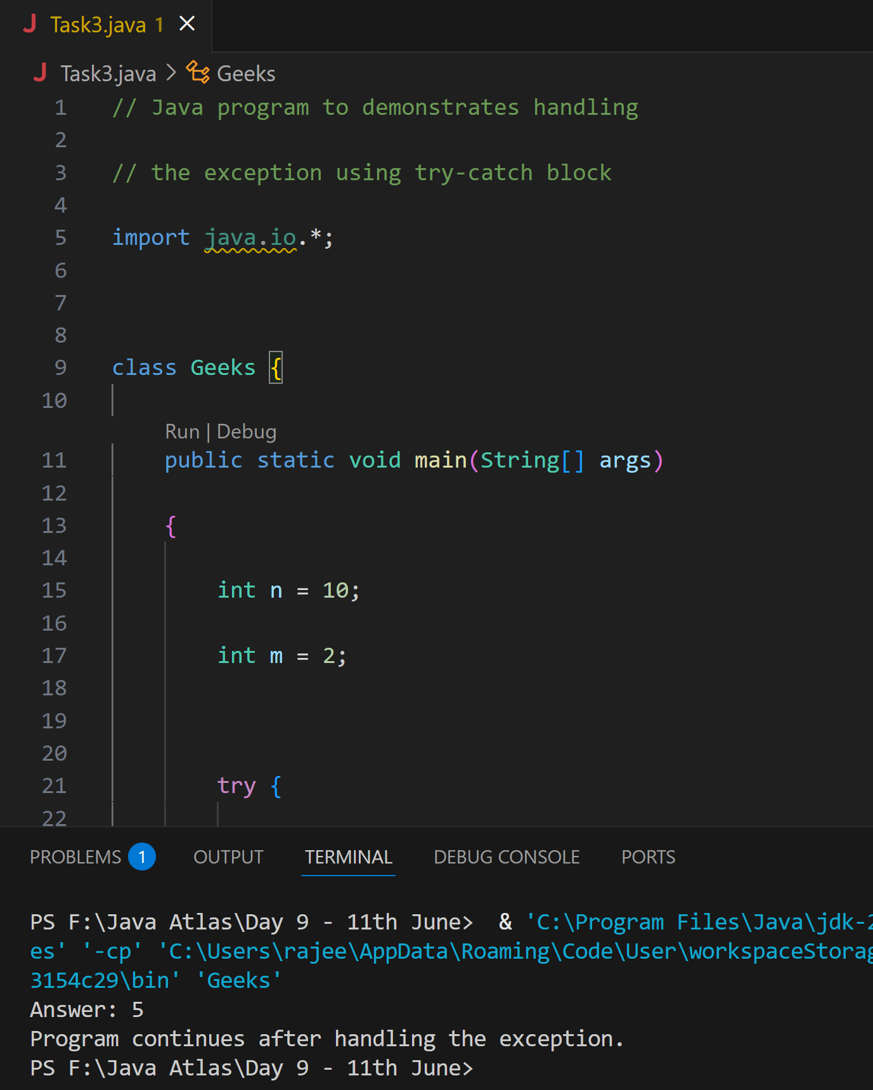

**Task 4:**

**List of checked and unchecked exceptions**.

**Ans:**

**Checked Exceptions**: IOException, FileNotFoundException, SQLException, ClassNotFoundException, InterruptedException, ParseException, MalformedURLException, NoSuchMethodException.

**Unchecked Exceptions**: ArithmeticException, NullPointerException, ArrayIndexOutOfBoundsException, StringIndexOutOfBoundsException, NumberFormatException, IllegalArgumentException, IllegalStateException, ClassCastException.

**Task 5:**

**Try with Multiple catch blocks  ….** **Execute the below code snippet n display the out .. along with reason..**

public class ExcepTest {

   public static void main(String args[]) {

      try {

         int a[] = new int[2];

         int b = 0;

         int c = 1/b;

         System.out.println("Access element three :" + a[3]);

      }

      catch (ArrayIndexOutOfBoundsException e) {

         System.out.println("ArrayIndexOutOfBoundsException thrown  :" + e);

      }catch (Exception e) {

          System.out.println("Exception thrown  :" + e);

      }

      System.out.println("Out of the block");

   }

}

**Ans:** Exception thrown  :java.lang.ArithmeticException: / by zero  
Out of the block

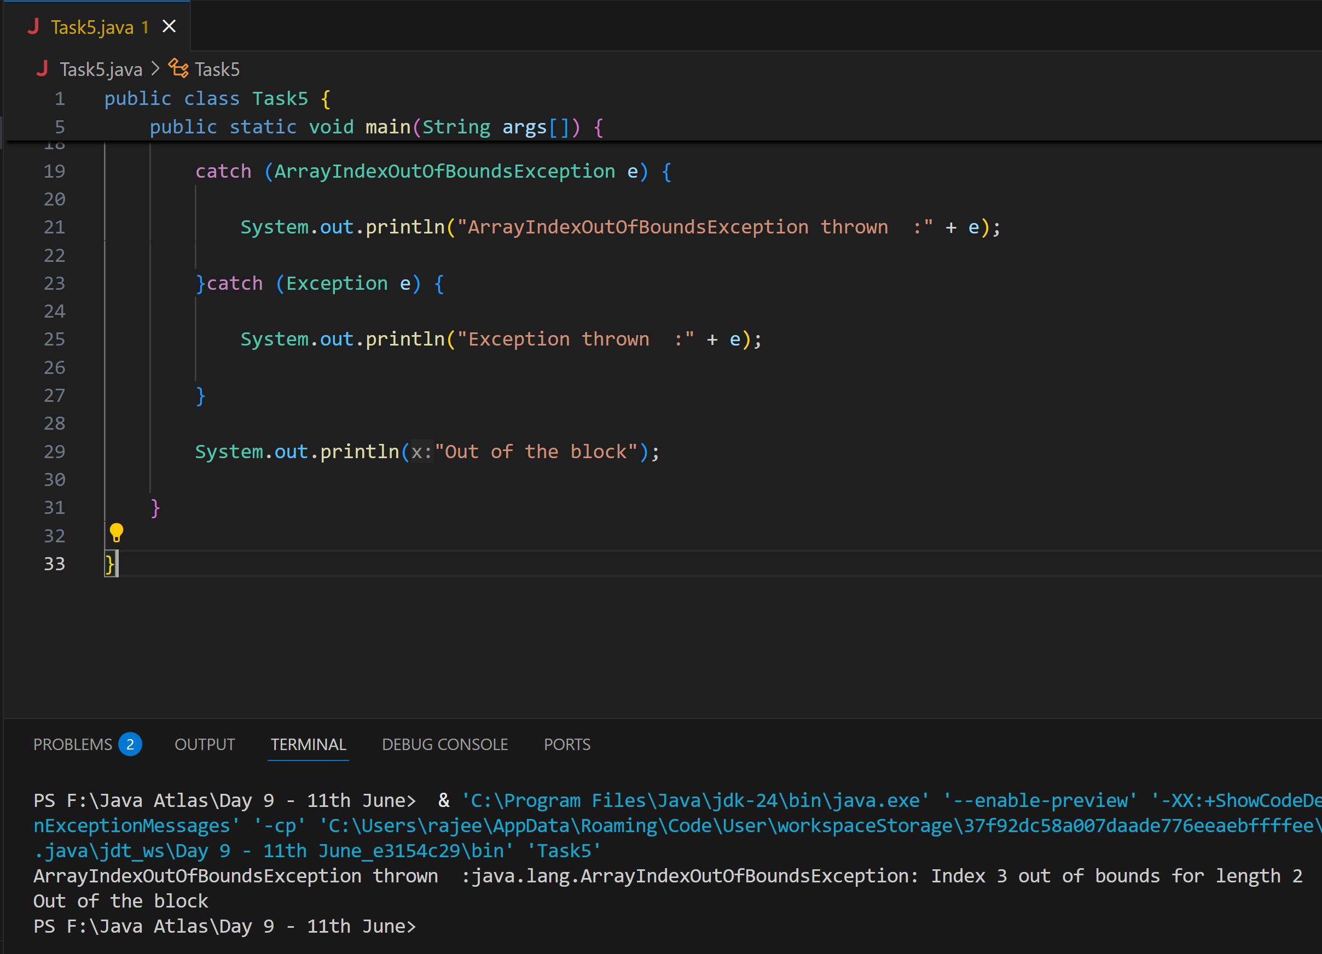

**Task 6:**

**What is the output of the below code… give your  reason for the output**

public class ExcepTest {

   public static void main(String args[]) {

      try {

         int a[] = new int[2];

         int b = 0;

         int c = 1/b;

         System.out.println("Access element three :" + a[3]);

      }

      catch (ArithmeticException e) {

         System.out.println("ArithmeticException thrown  :" + e);

      }

      catch (ArrayIndexOutOfBoundsException e) {

         System.out.println("ArrayIndexOutOfBoundsException thrown  :" + e);

      }catch (Exception e) {

          System.out.println("Exception thrown  :" + e);

      }

      System.out.println("Out of the block");

   }

}

**Ans:**

ArithmeticException thrown  :java.lang.ArithmeticException: / by zero  
Out of the block

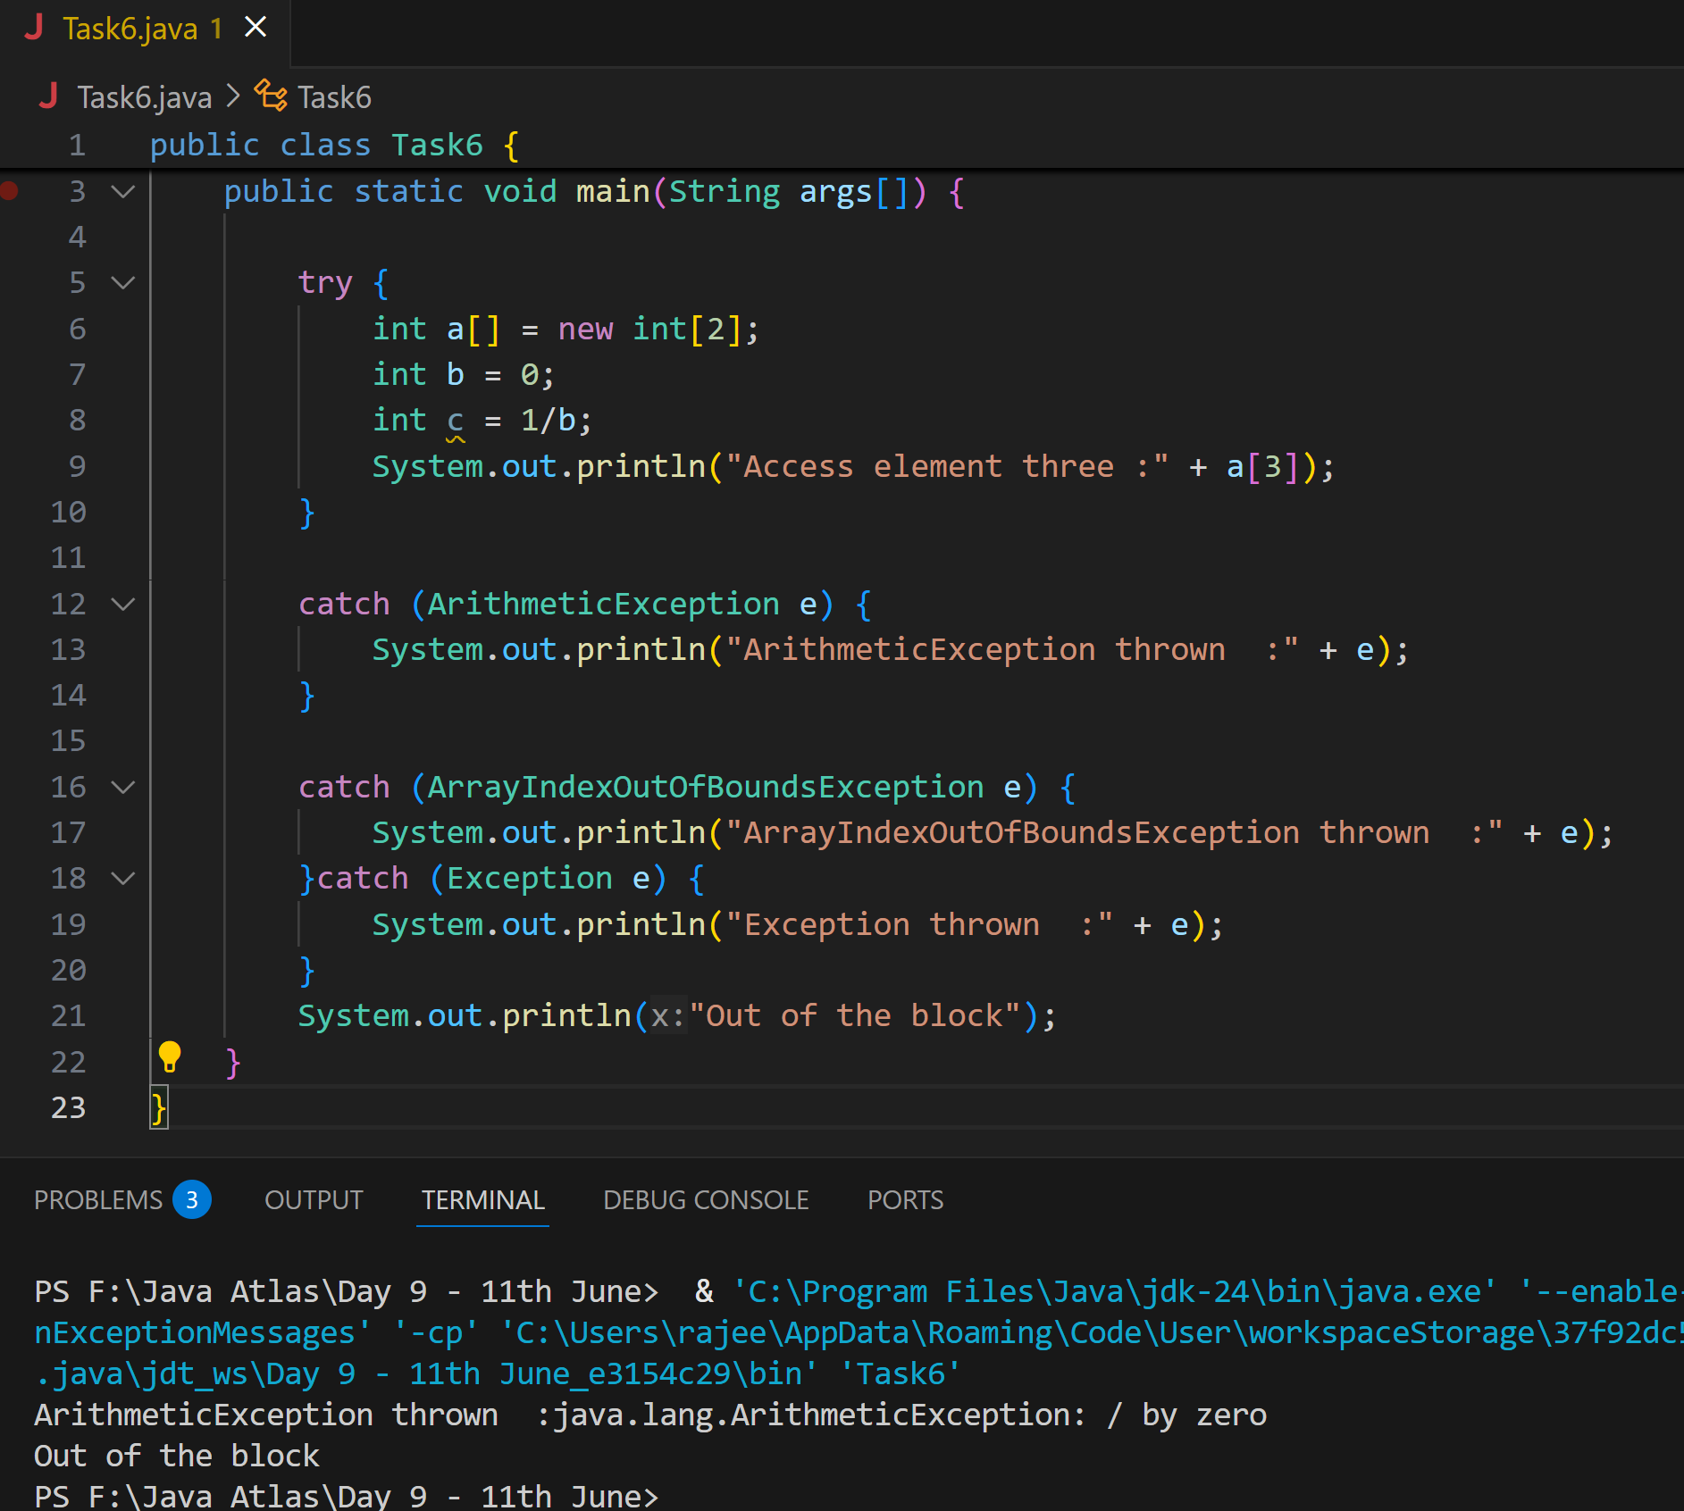

**Task 7:**

**In the below code we are having use multiple catch in a single statement: find the output and try to understand the code..**

public class ExcepTest {

   public static void main(String args[]) {

      try {

         int a[] = new int[2];

         int b = 0;

         int c = 1/b;

         System.out.println("Access element three :" + a[3]);

      }

      catch (ArrayIndexOutOfBoundsException | ArithmeticException e) {

         System.out.println("Exception thrown  :" + e);

      }

      System.out.println("Out of the block");

   }

}

**Ans:**

Exception thrown  :java.lang.ArithmeticException: / by zero  
Out of the block

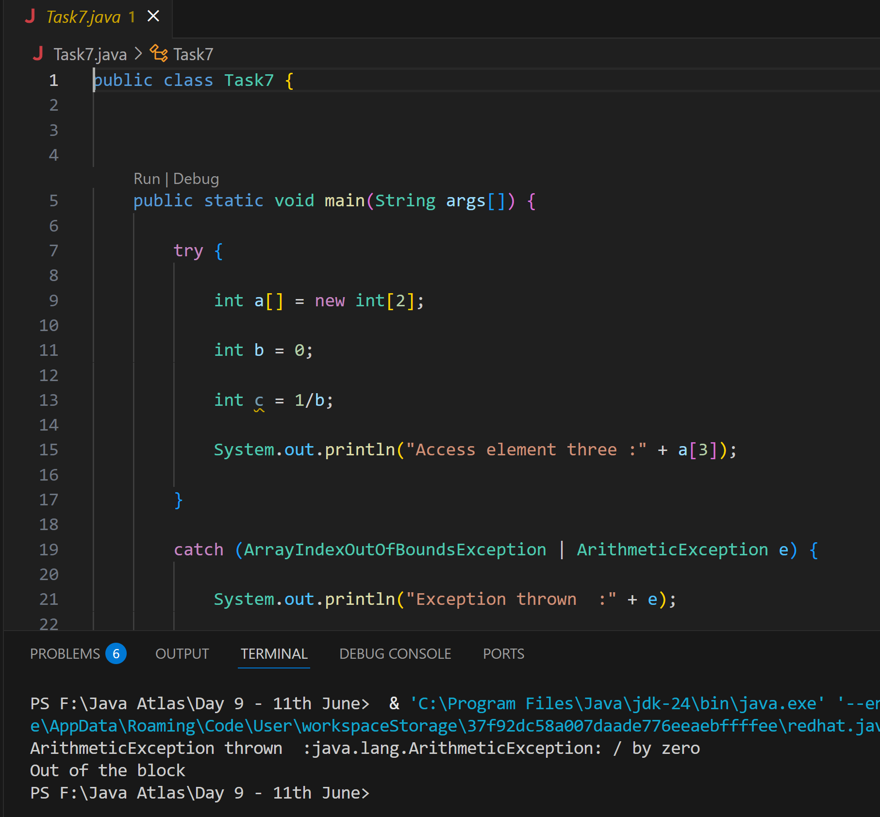

**Task 8:**

public class ExcepTest {

   public static void main(String args[]) {

      try {

         int a[] = new int[2];

         try {

            int b = 0;

            int c = 1/b;

         }catch(Exception e) {

            System.out.println("Exception thrown: " + e);

         }

         System.out.println("Access element three :" + a[3]);

      }

      catch (ArrayIndexOutOfBoundsException e) {

         System.out.println("Exception thrown: " + e);

      }

      System.out.println("Out of the block");

   }

}

**Ans:**

Exception thrown: java.lang.ArithmeticException: / by zeroException thrown:

java.lang.ArrayIndexOutOfBoundsException: Index 3 out of bounds for length 2

Out of the block

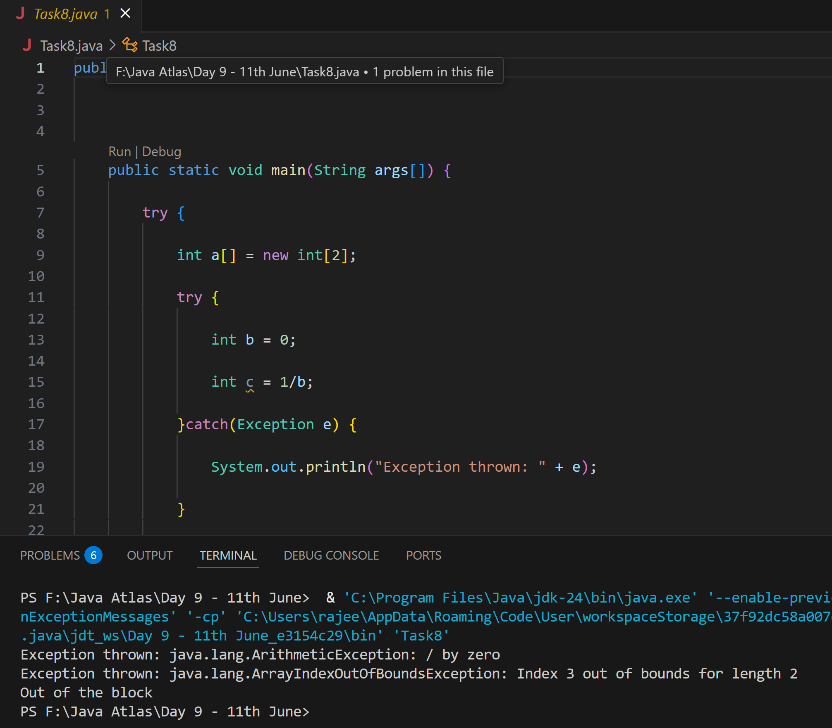

Throw and Throws:

**Task 9**

// Demonstrating how to throw an exception

class MyClass {

    static void fun() throws IllegalAccessException

    {

        System.out.println("Inside fun(). ");

        throw new IllegalAccessException("demo");

    }

    public static void main(String args[])

    {

        try {

            fun();

method2();   → arrayindex…

Method3()  —> file not found….

        }

        catch (IllegalAccessException e) {

            System.out.println("Caught in main.");

        }

    }

}

**Ans:**

Inside fun().   
Caught in main.

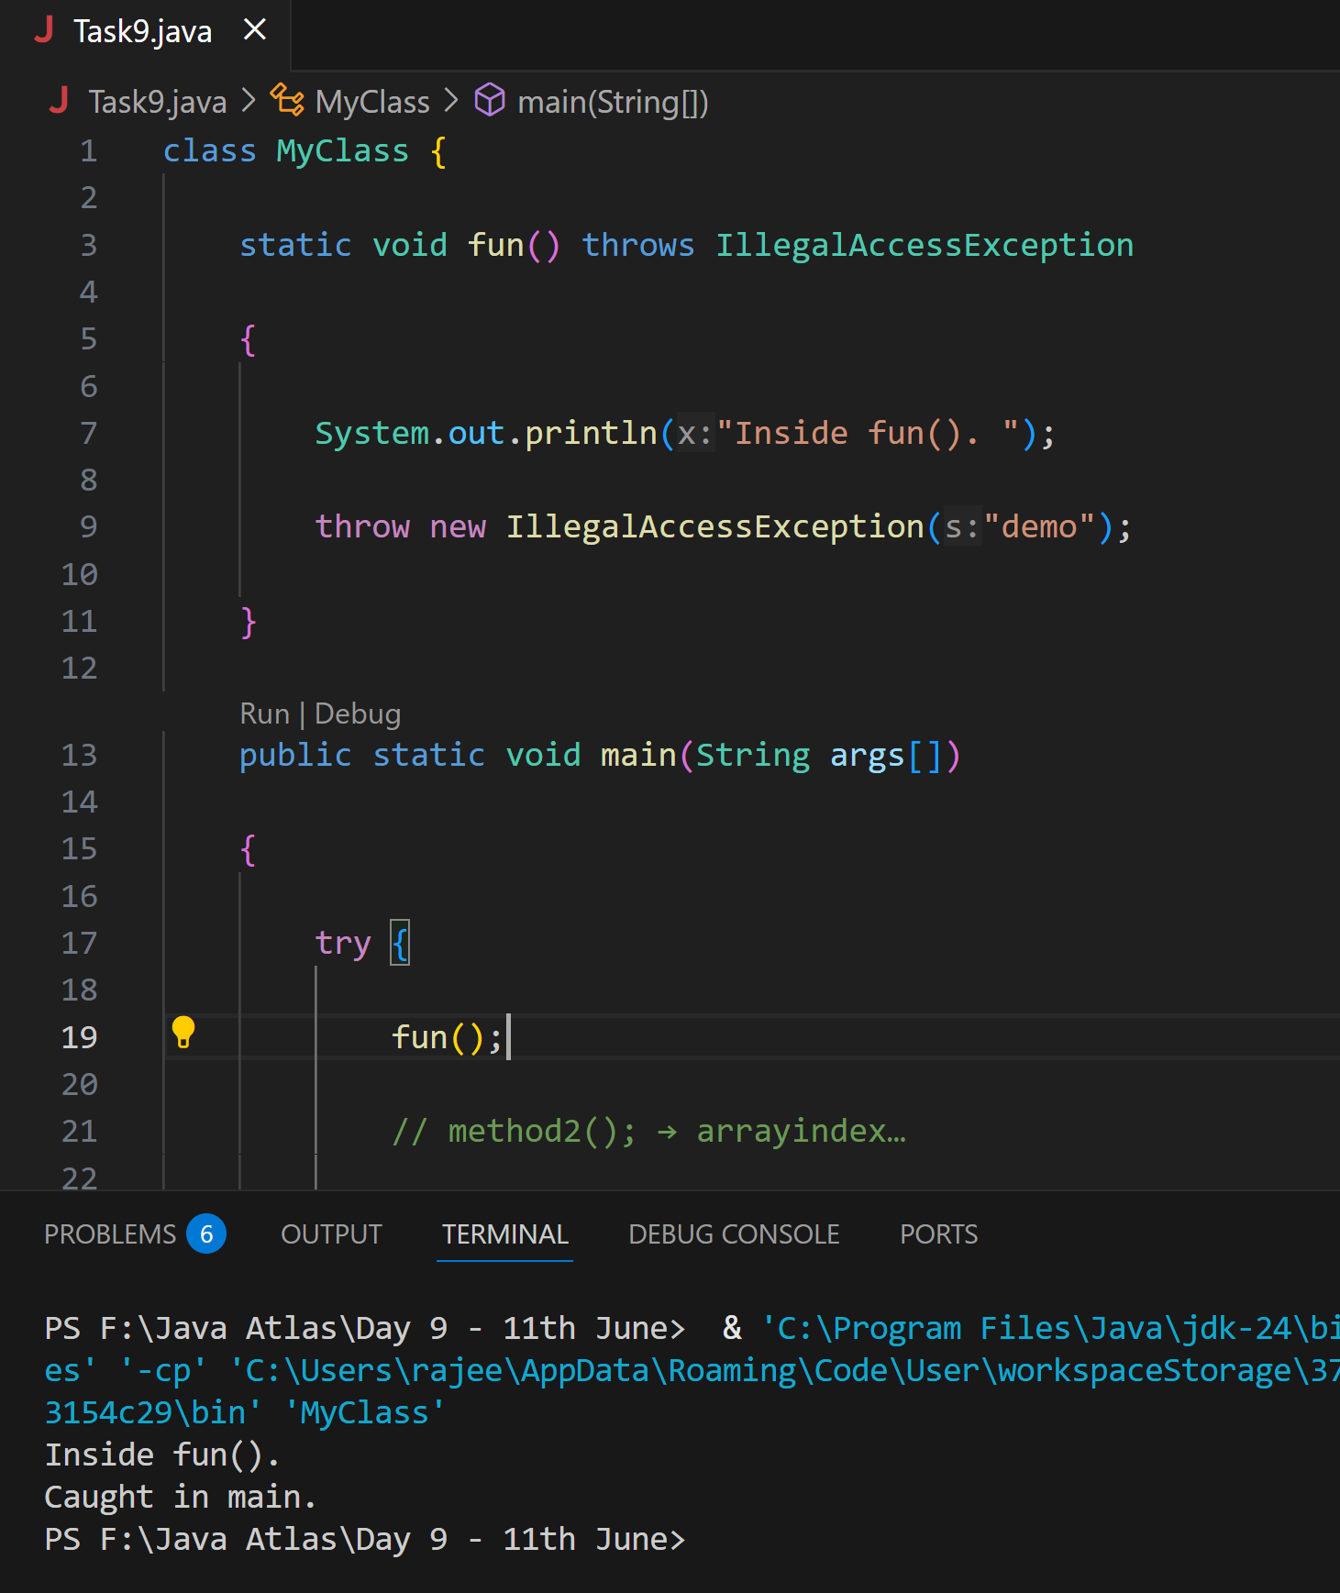

**Task 10:**

import java.util.ArrayList;

class Main {

    public static void main (String[] args) {

               // Creating an ArrayList

       ArrayList<Integer> a = new ArrayList<Integer>();

       // Adding Element in ArrayList

       a.add(1);

       a.add(2);

       a.add(3);

             // Printing ArrayList

       System.out.println(a);

    }

}

**Ans:**

[1, 2, 3]

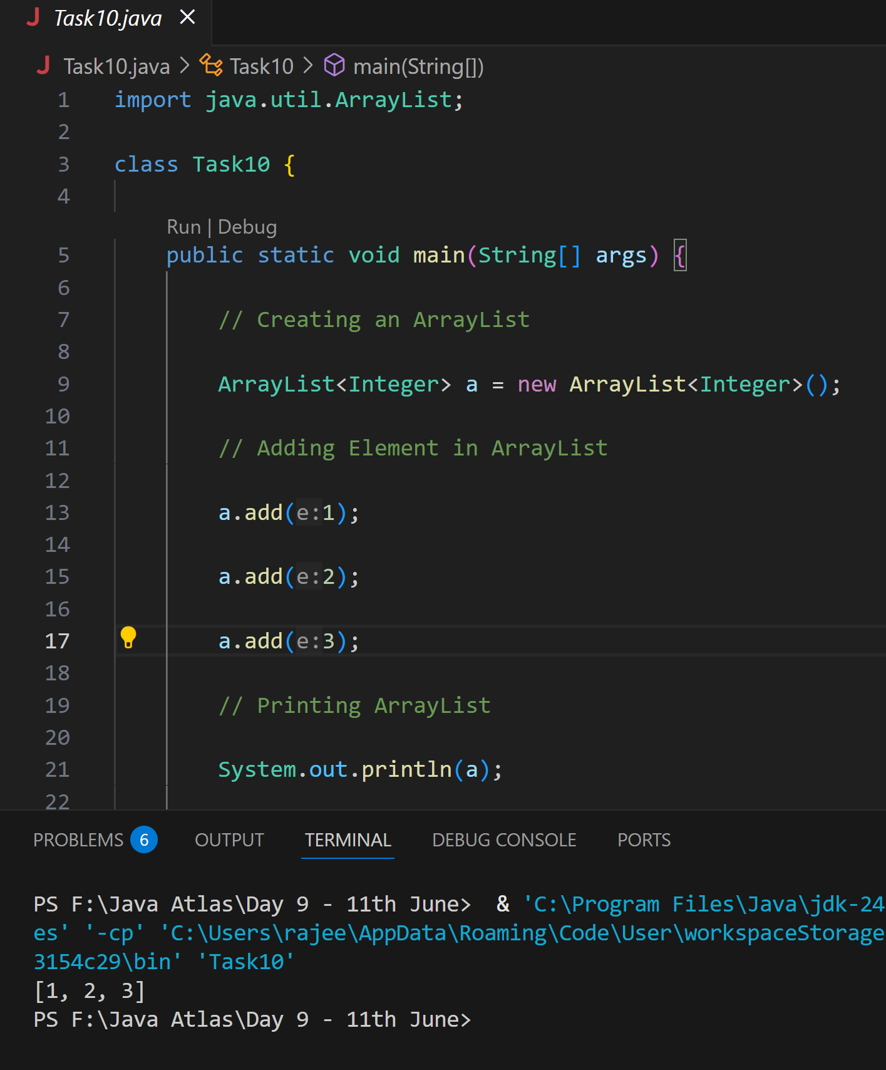

**Task 11**

**Wap to create an array list to display 10 elements using for loop.**

**Ans:**

import java.util.ArrayList;

public class Task11 {

    public static void main(String[] args) {

        ArrayList<Integer> list = new ArrayList<>();

        for (int i = 1; i <= 10; i++) {

            list.add(i);

        }

        System.out.println("ArrayList Elements:");

        for (int i = 0; i < list.size(); i++) {

            System.out.println("Element at index " + i + ": " + list.get(i));

        }

    }

}

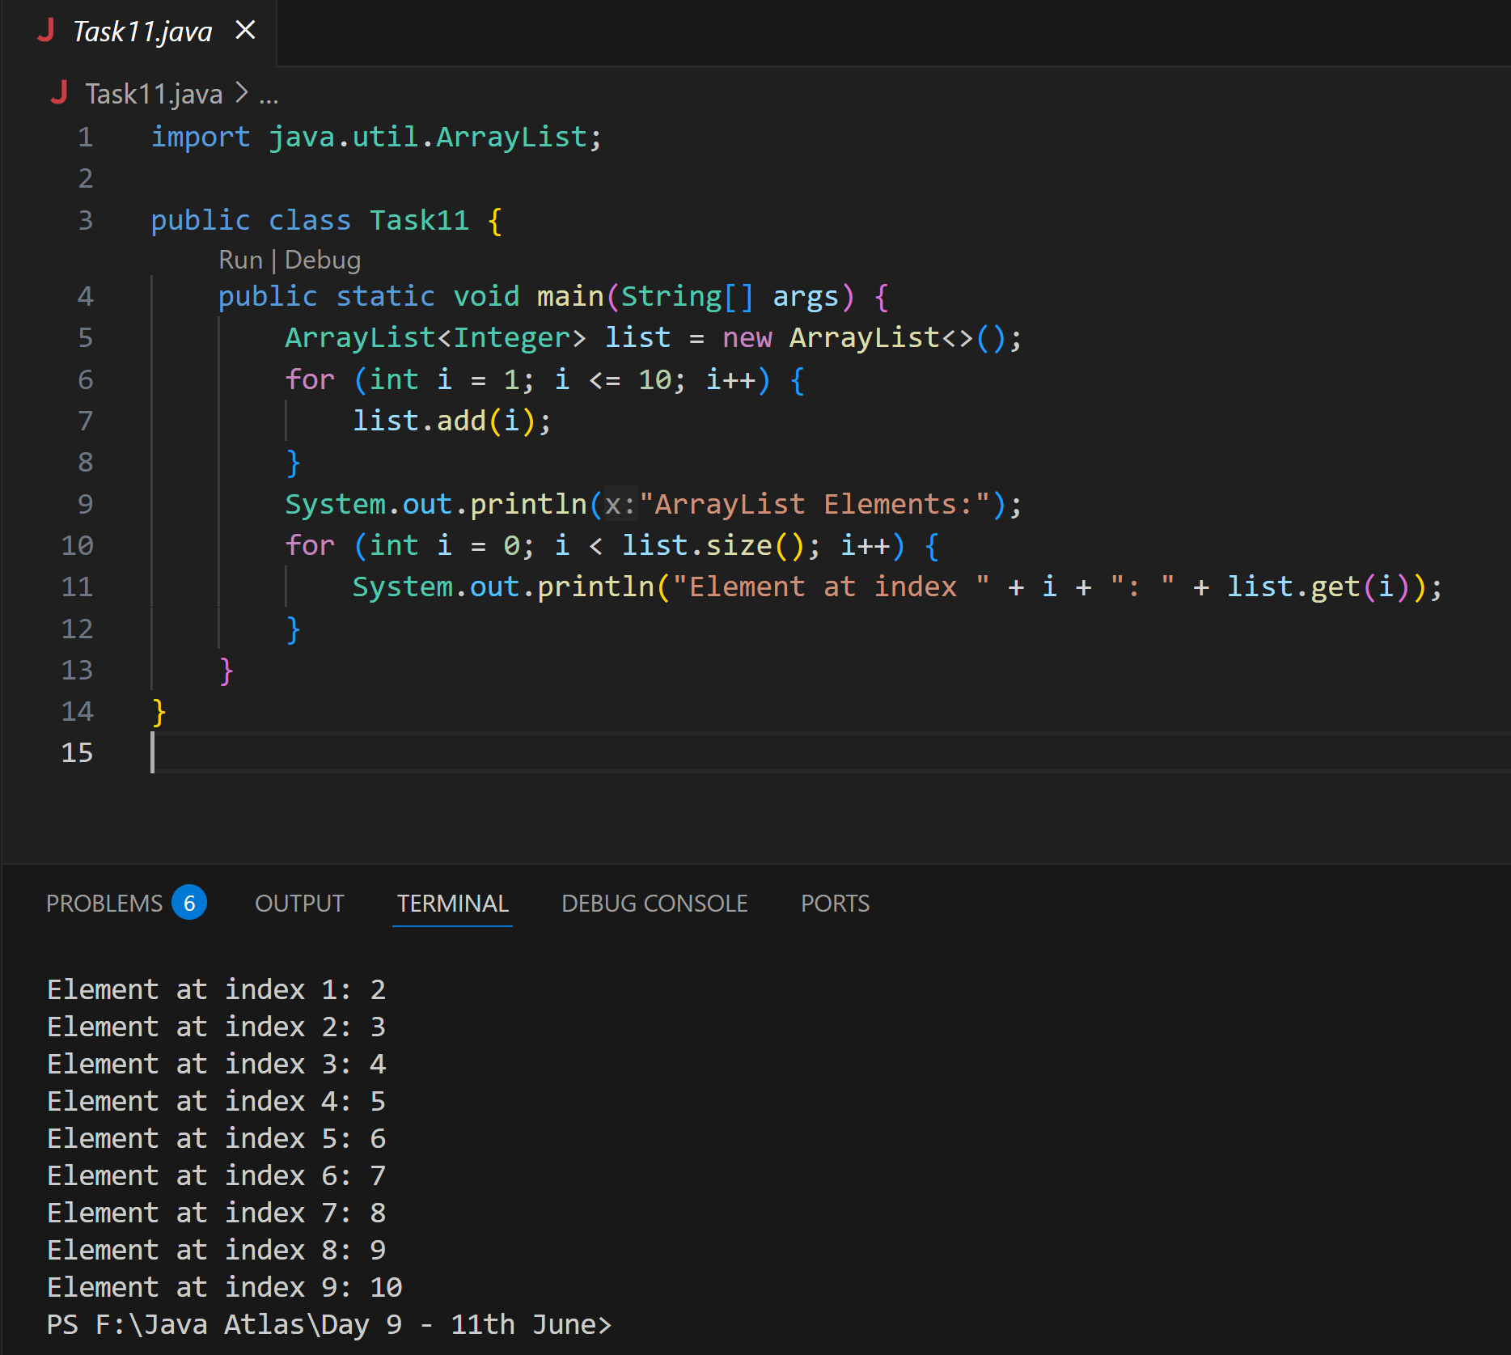

**Task 12**

**Find the output of the be code snippet..**

// Addition, Deletion and Updation of Element

import java.util.*;

class Main {

    public static void main(String args[]){

        ArrayList<String> al = new ArrayList<>();

        al.add("Prasunamba");

        al.add("Meher");

       System.out.println("Orignal List : "+al);

        al.add(1, "Hello");

       System.out.println("After Adding element at index 1 : "+ al);

       al.remove(0);

       System.out.println("Element removed from index 0 : "+ al);

       al.remove("Prasunamba");

       System.out.println("Element Prasunamba removed : "+ al);

        al.set(0, "K");

        System.out.println("List after updation of value : "+al);

    }

}

**Ans:**

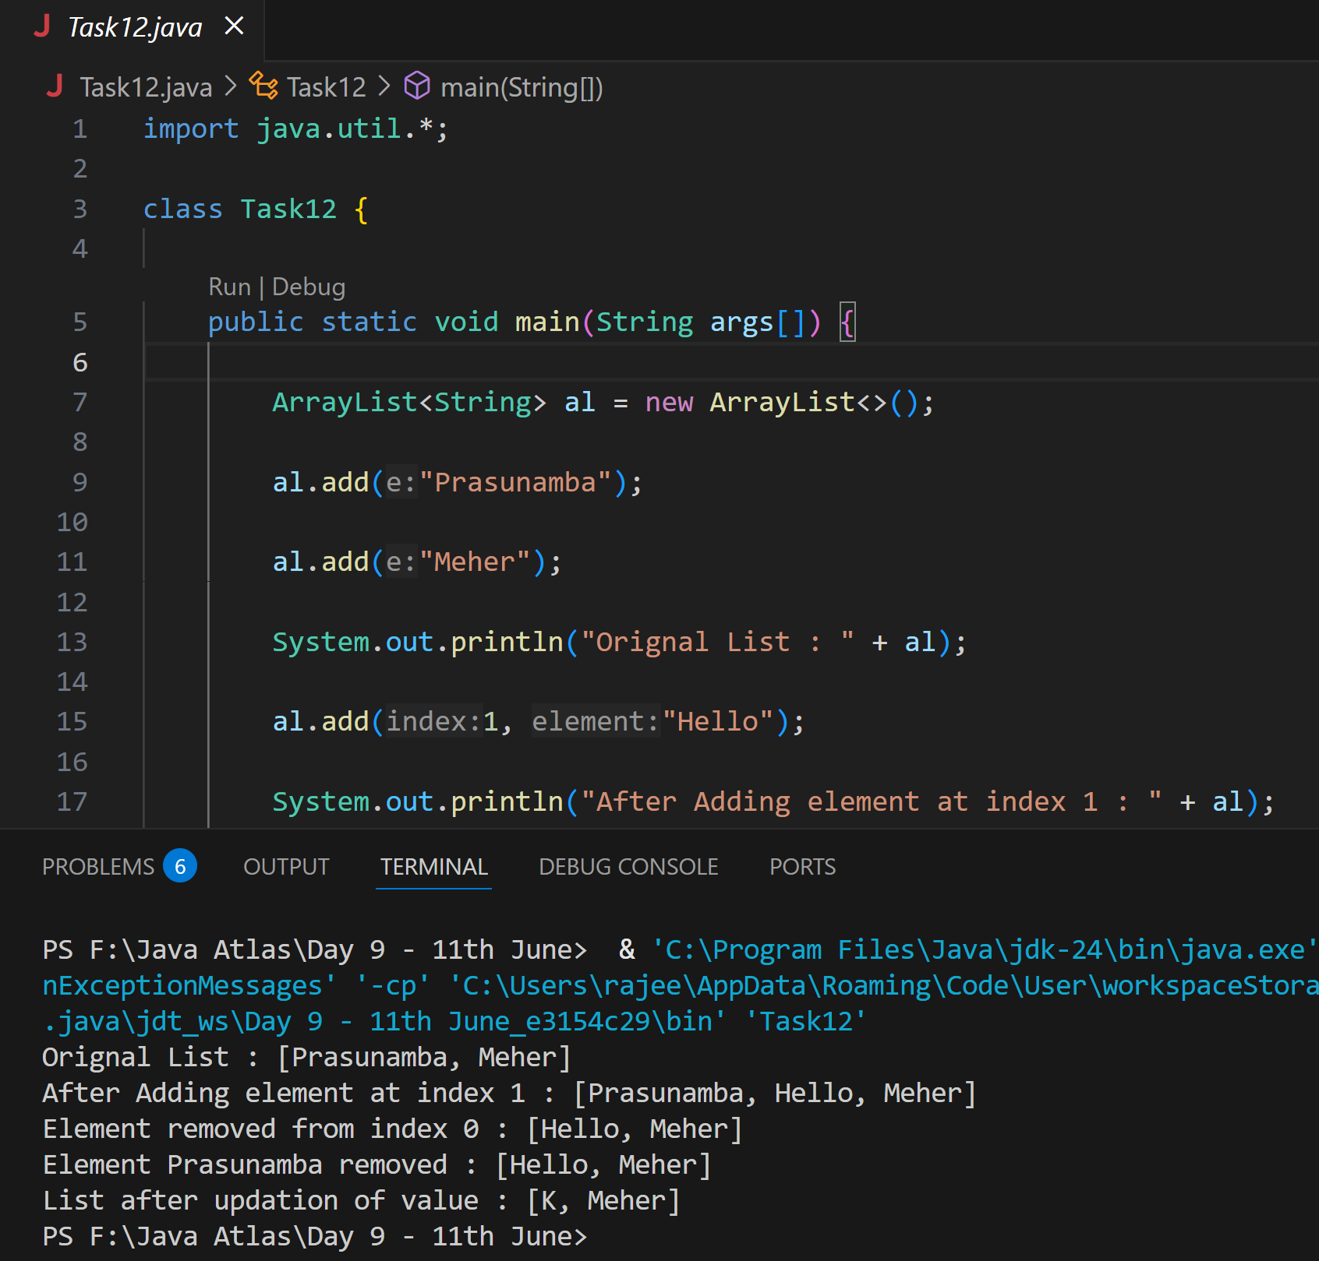

**Task 13**

**User defined Exception:**

// A Class that represents user-defined exception

class Customer extends Exception {// predefined class Exception

    public Customer(String m) { // constructor with parameters

        super(m); // parent class constructor

    }

}

// A Class that uses the above MyException

public class setText {

    public static void main(String args[]) {

        try {

            // Throw an object of user-defined exception

            throw new MyException("This is a custom exception");

        }

        catch (MyException ex) {

            System.out.println("Caught");

            System.out.println(ex.getMessage());

        }

    }

}

Ans:

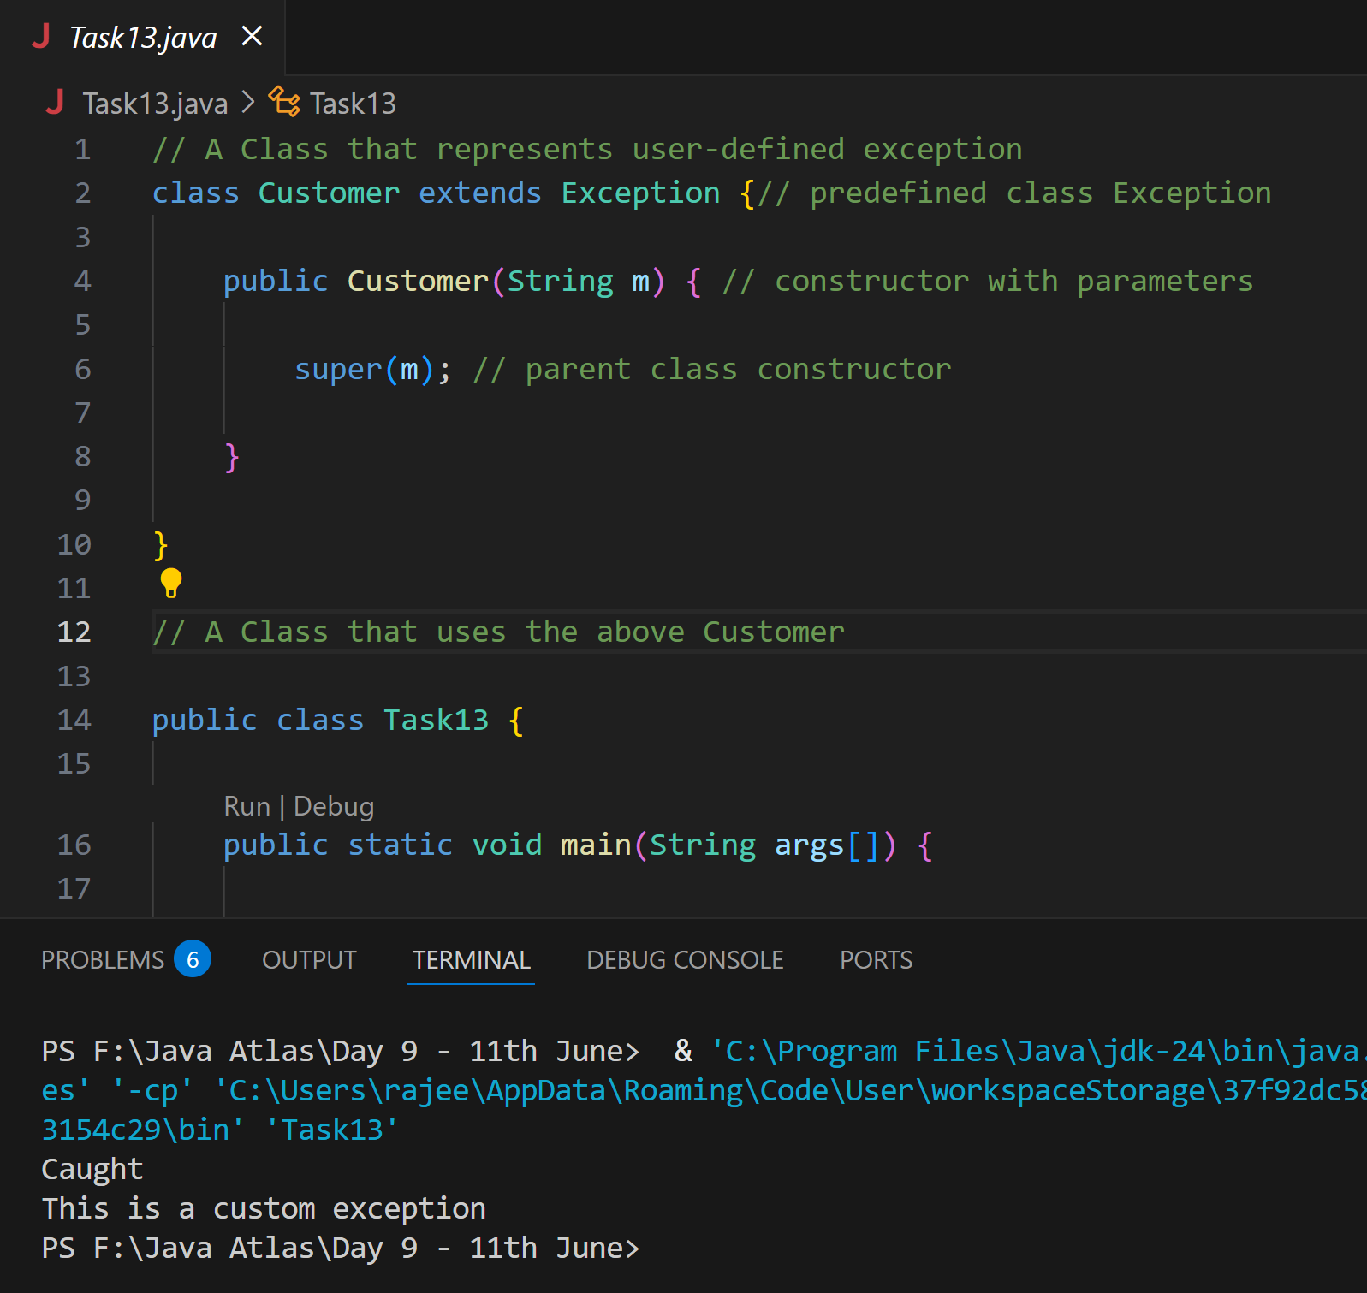

**Task 14**

Inheritance

Classes customer, employee, Manager  … 2 variables in each class

Driver class – display all the variables… toString();

Hint : use getter and setters..

**Ans:**

class Person {

    private String name;

    private int id;

    public String getName() {

        return name;

    }

    public void setName(String name) {

        this.name = name;

    }

    public int getId() {

        return id;

    }

    public void setId(int id) {

        this.id = id;

    }

    @Override

    public String toString() {

        return "Name: " + name + ", ID: " + id;

    }

}

class Employee extends Person {

    private String department;

    private double salary;

    public String getDepartment() {

        return department;

    }

    public void setDepartment(String dept) {

        this.department = dept;

    }

    public double getSalary() {

        return salary;

    }

    public void setSalary(double sal) {

        this.salary = sal;

    }

    @Override

    public String toString() {

        return super.toString() + ", Department: " + department + ", Salary: " + salary;

    }

}

class Manager extends Employee {

    private int teamSize;

    private String level;

    public int getTeamSize() {

        return teamSize;

    }

    public void setTeamSize(int size) {

        this.teamSize = size;

    }

    public String getLevel() {

        return level;

    }

    public void setLevel(String lvl) {

        this.level = lvl;

    }

    @Override

    public String toString() {

        return super.toString() + ", Team Size: " + teamSize + ", Level: " + level;

    }

}

public class Task14 {

    public static void main(String[] args) {

        Manager manager = new Manager();

        manager.setName("Rajeev");

        manager.setId(1112);

        manager.setDepartment("IT");

        manager.setSalary(850000.50);

        manager.setTeamSize(5);

        manager.setLevel("Senior");

        System.out.println(manager.toString());

    }

}

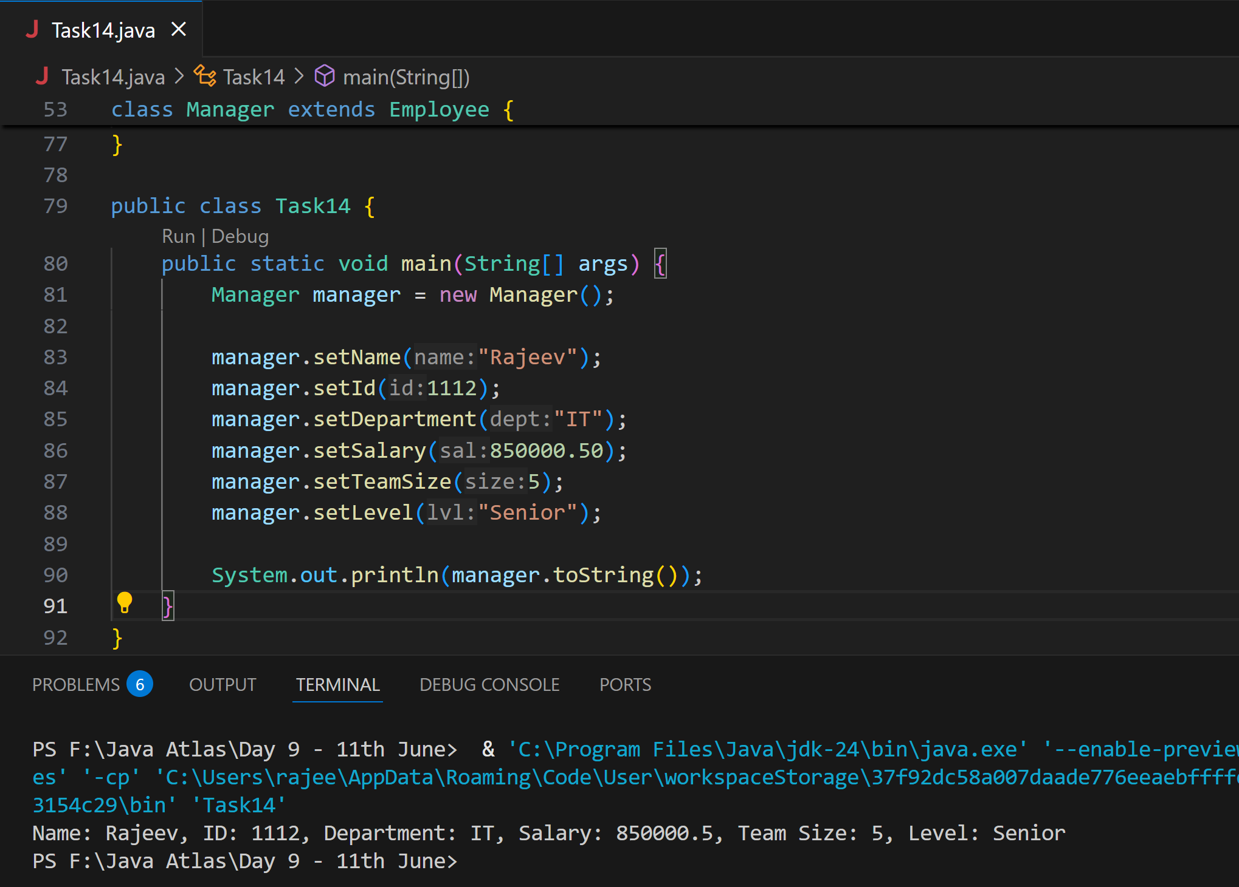

Inner classes

**Task 15**

What is the output of the below code snippet..  Explain ..

class OuterClass {

  int x = 10;

  class InnerClass {

    int y = 5;

  }

}

public class Main {

  public static void main(String[] args) {

    OuterClass myOuter = new OuterClass();

    OuterClass.InnerClass myInner = myOuter.new InnerClass();

    System.out.println(myInner.y + myOuter.x);

  }

}

**Ans: 15**

Inner classes can access members of the outer class directly. We can only instantiate a non-static inner class using an instance of the outer class. This is also an example of member inner classes in Java.

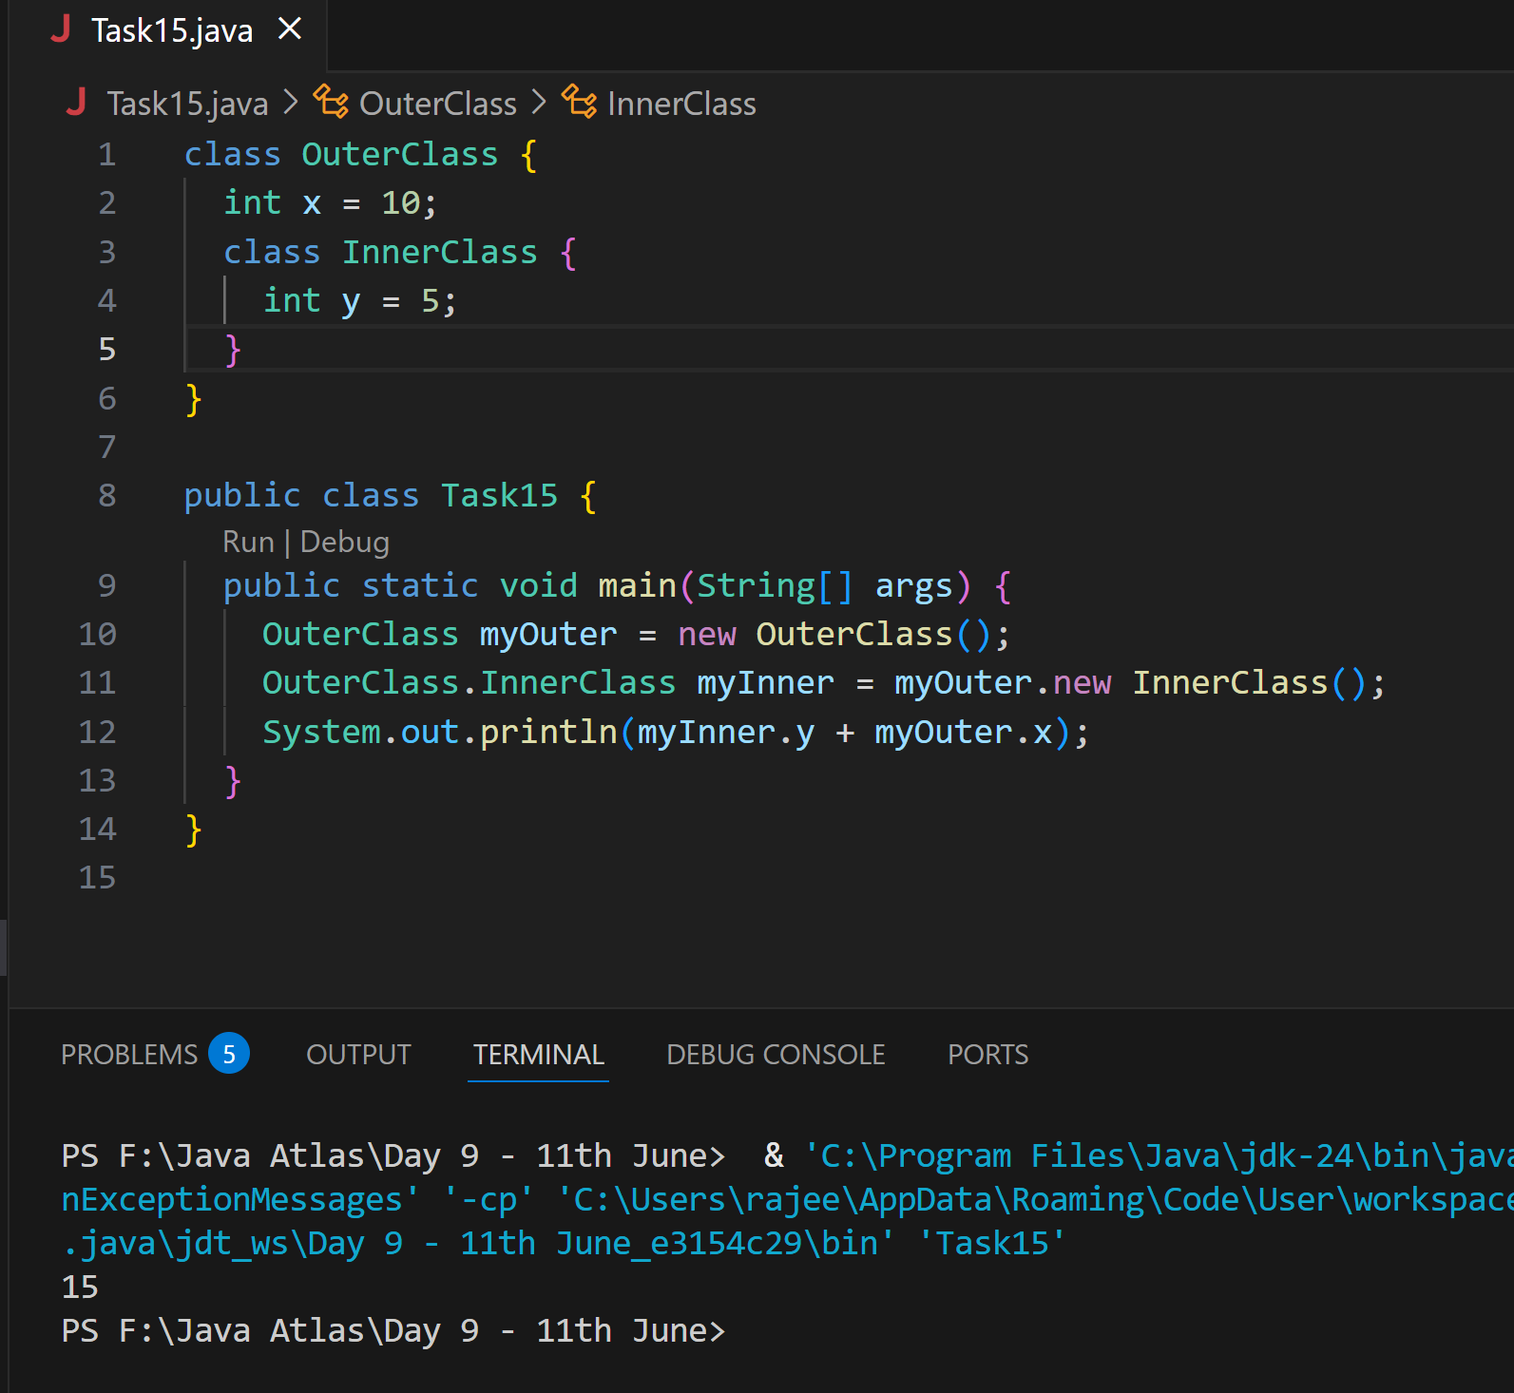

**Task 016**

Use the above code and make the inner class as private and see the output..

Ex: Private  class InnerClass {

**Ans:**

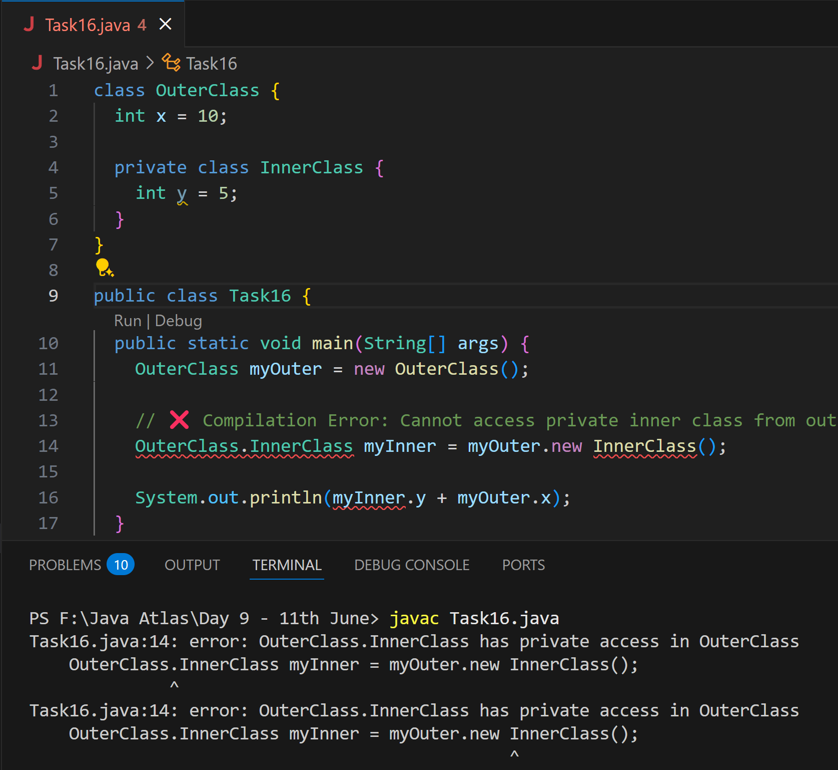

**Task 17**

Use the above code Task 015 and make the inner class static … see the output and explain..

Ex: static class InnerClass {

**Ans:**

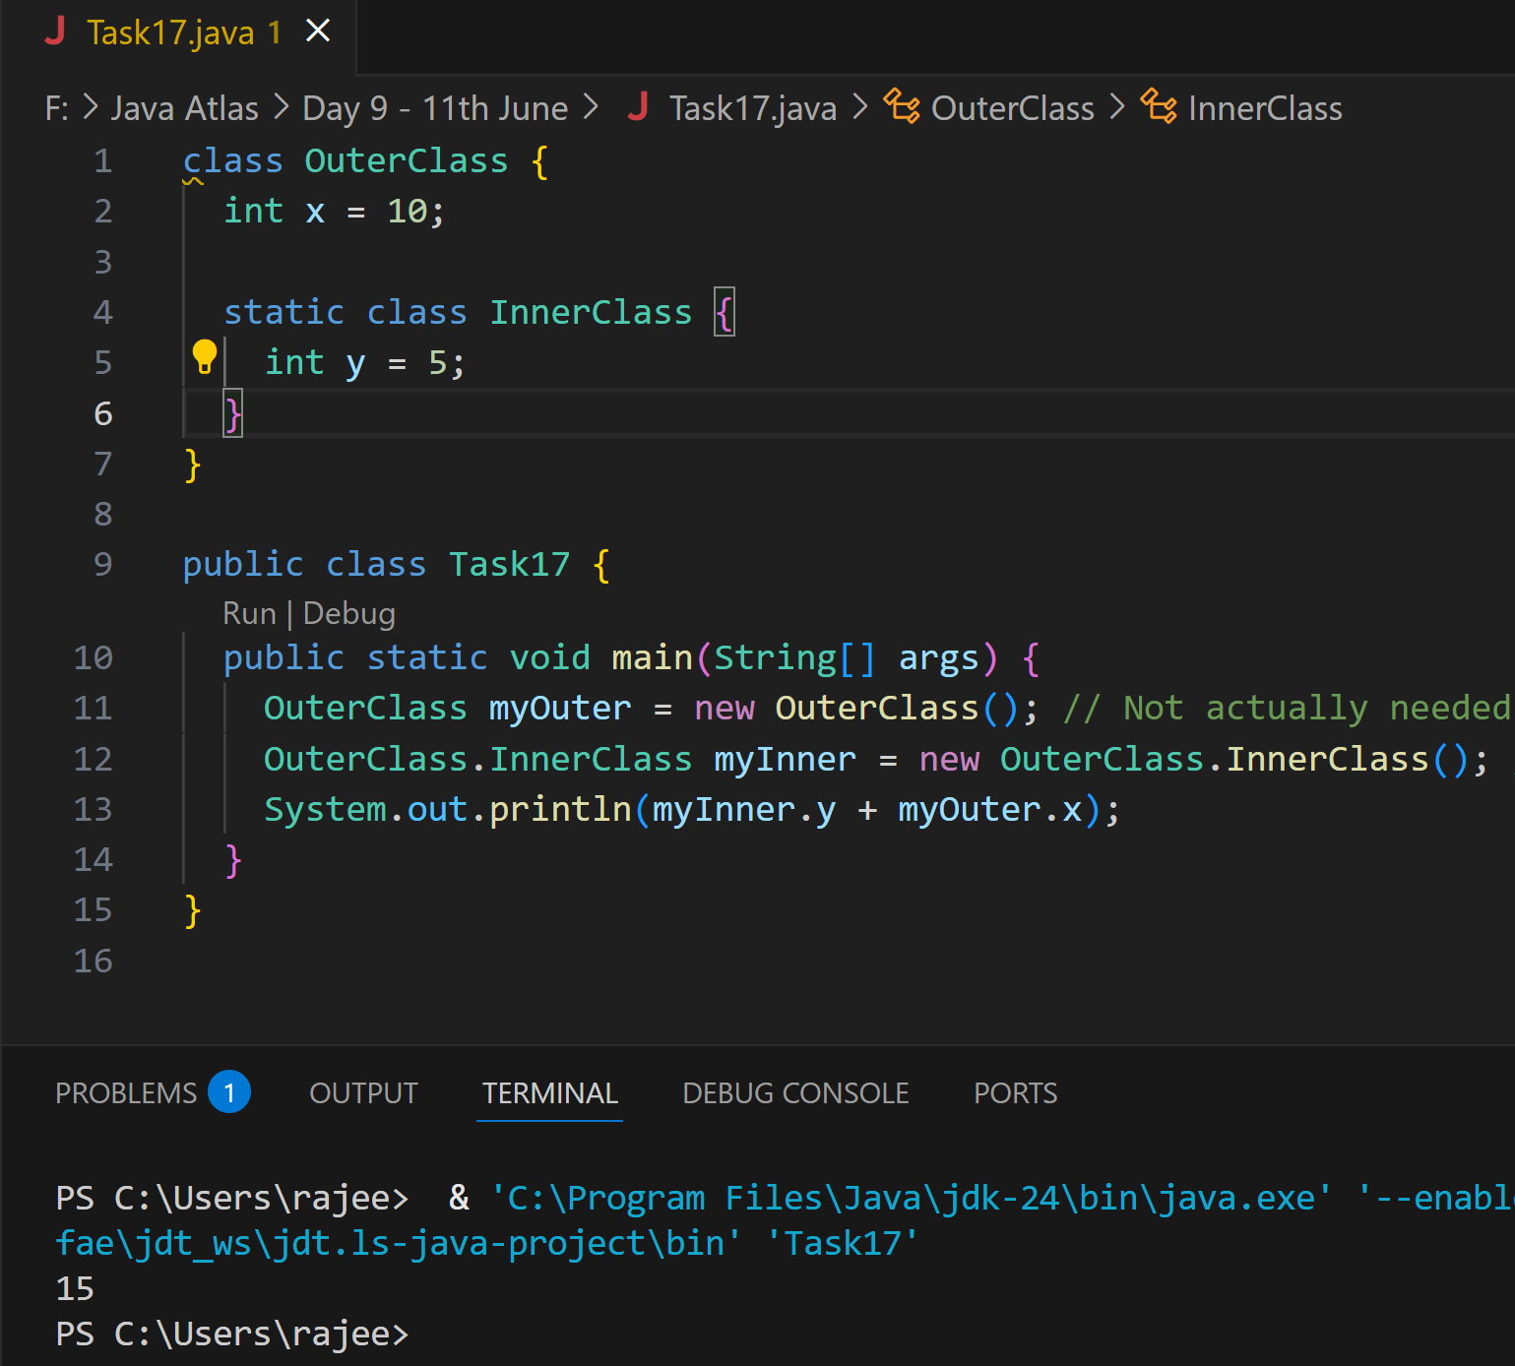

**Task 018**

Use the above code Task 015 and create a method in innerclass and return the outer class variable

class OuterClass{

Int x = 50;

Class InnerClass {

Public int innerMethod() {

Return x;

}

}

}

**Ans:**

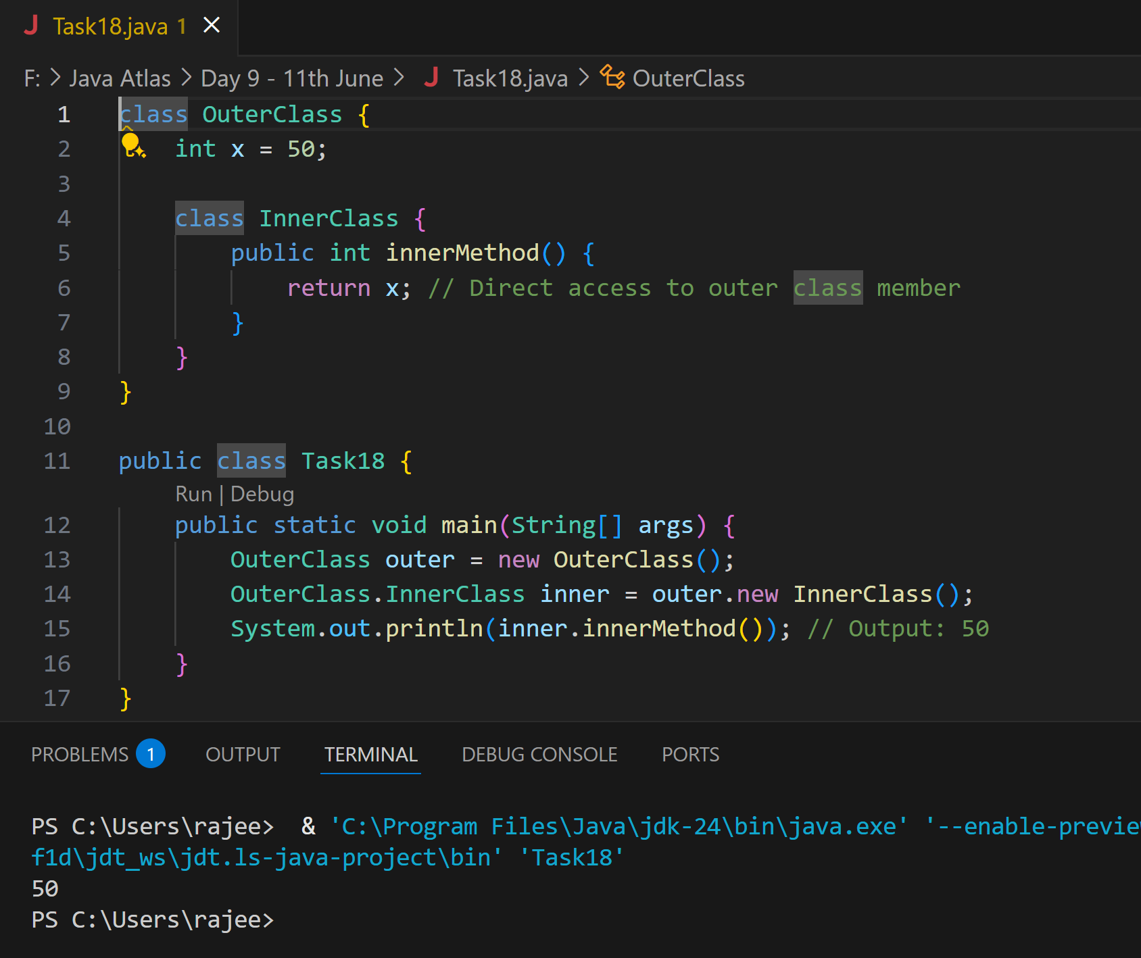

**Task 19  — query by vivek**

class OuterClass {

  int x = 10;

  static class InnerClass {

    static int y = 5;

  }

}

public class Main {

  public static void main(String[] args) {

     OuterClass.InnerClass myInner = new OuterClass.InnerClass();

    System.out.println(myInner.y);

  }

}

**Ans:**

